FELLOWSHIP ON RADIOLOGY COURSE FOR PHYSICAL THERAPISTS

MODULE 6
ASSIGNMENT:
RADIOLOGICAL EVALUATION OF FRACTURES

Ajin Jayan Thomas

May 21, 2014

Evaluation of a fracture is one of the most important skills of a physiotherapist. Knowing the site, extent, type, alignment, direction, associated abnormalities, and special type of fractures has been described by Greenspan as the elements of fracture description. Making use of this knowledge is very essential for a physiotherapist in assessing a patient, determining goals of treatment and also for establishing a baseline upon which subsequent radiological evaluation can be performed to determine the outcome of treatment.
Although evaluation of a fracture is of utmost importance, it is equally important to understand anatomical variations of bones in order to determine what can be considered as normal and what to consider in further evaluation. This becomes more difficult in the evaluation in the peadiatric age group. Although the young bone has the ability to heal rapidly and to remodel itself, the main area of thought will be if it is a potential for disruption of growth.
Many conditions may mimic a fracture on the radiograph but on closer examination it becomes more evident that they may be just normal anatomical structures. Some examples can be the following:
- Accessory bones
- Epiphysis
- Juxta articular calcifications
- Multipartite conditions
- Nutrient foramina
- Sesamoids
Accessory Bones
These may be commonly found in the foot and less often in the wrist and shoulder. Some of the common accessory bones of the foot are os peroneum, os subfibulare, os subtibiale, os tibiale externum (accessory navicular), os trigonum, os calcaneus secundaris, os intermetatarseum, os supratalare, bipartite hallux sesamoid, os supranaviculare.

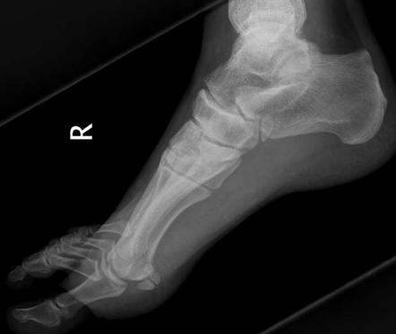

Os Tibiale Externum¹

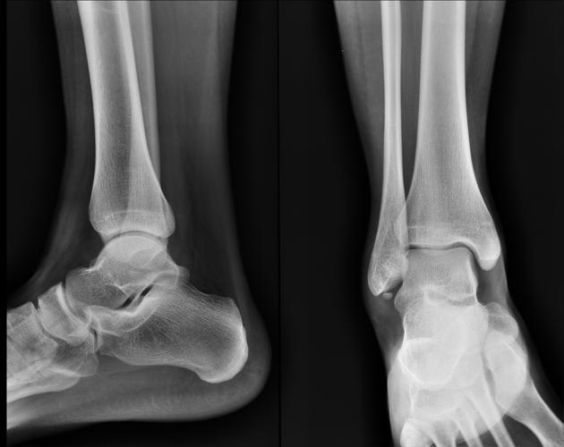

Os Subfibulare¹

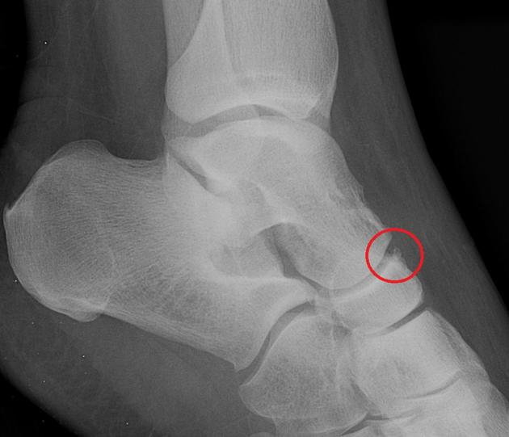

Os Supranaviculare¹

Accessory bones of the wrist may commonly be the following, lunula, os styloideum, os triangulare, trapezium secondarium, os epilunate, os hamuli proprium.

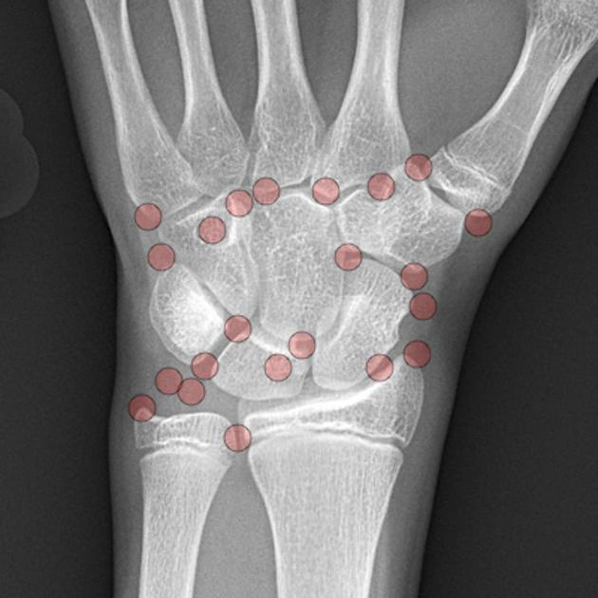

Positions of the accessory bones of the wrist²

Epiphysis
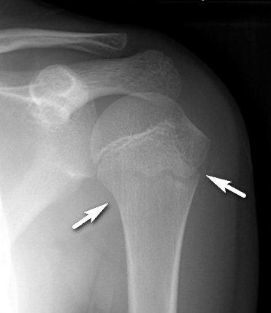
There may be multiple ossification centres which gives the epiphysis a communited appearance.

Normal Epiphyseal plate³

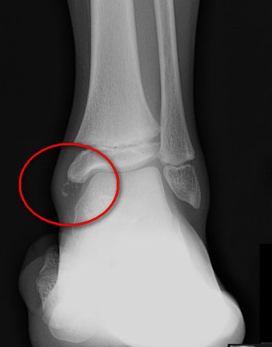

Accessory Epiphysis ³

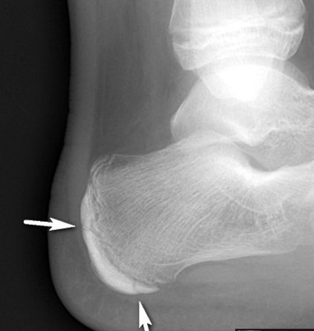

Multiple Ossification centres ³

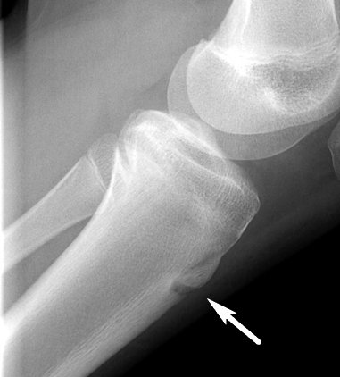

Normal apophysis of tibial tuberosity which usually fuses at 14- 18 years³

Juxta Articilar Calcifications
These are usually calcium deposits which are seen at the insertion of the tendons.
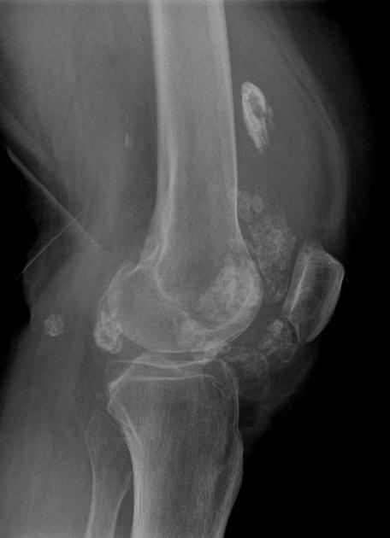

Synovial chondramatosis⁴

Multipartite Conditions
Examples may be bipartite or tripartite patella or a bipartite scaphoid.
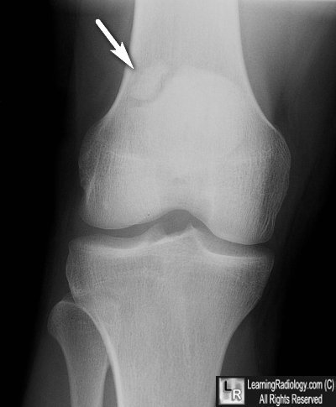

Bipartite Patella³

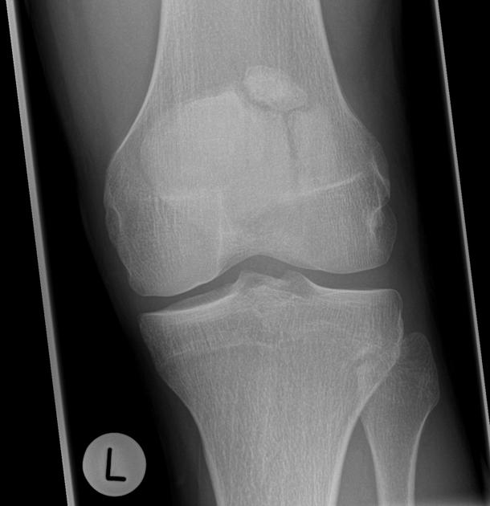

Tripartite Patella

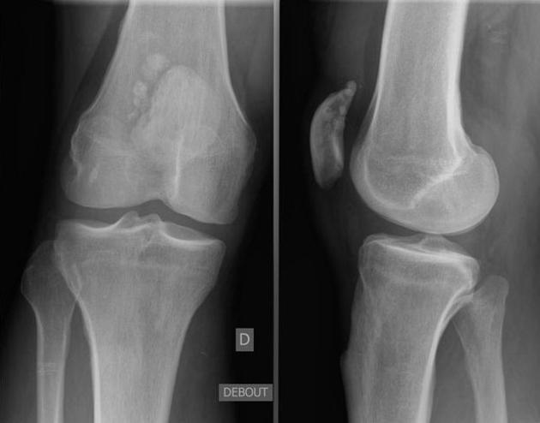

Multipartite Patella

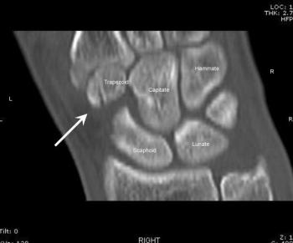

Bipartite Trapezoid⁵

Nutrient Foramina
Maybe seen as oblique radiolucency in shafts of long bones.
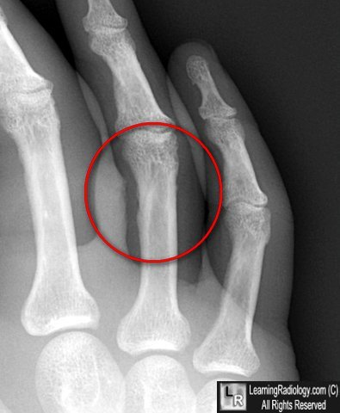

Nutrient foramina³

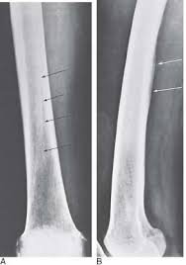

Nutrient foramin in long bones

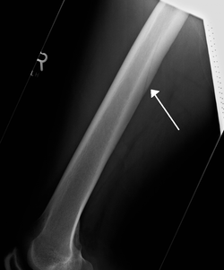

Nutrient foramin of the femur

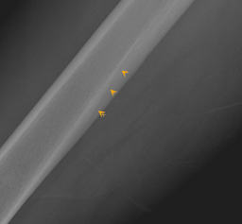

Of Femur⁶

Sesamoids
Usually seen in metacarpal and metatarsal heads, fabella and pisiform.

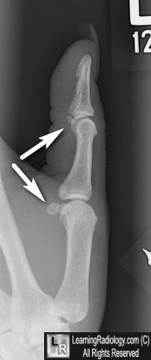

Sesamoids of the thumb³

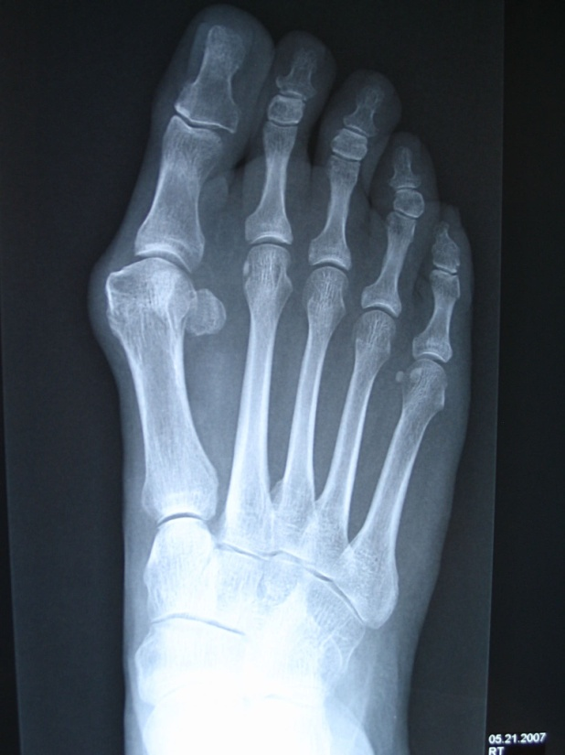

Sesamoids of the foot

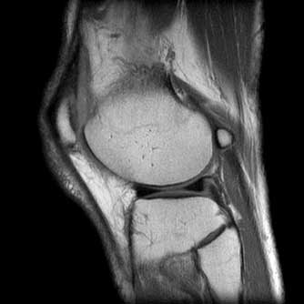

Os fabella⁷

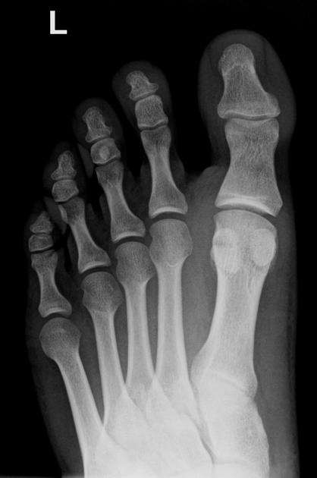

Hallux Sesamoid⁸

FRACTURES IN CHILDREN
Evaluation of fractures in children need special attention in that skeletally immature bone and joints may present a difficulty to diagnose trauma from a radiological perspective. Usually described based on the site of development such as metaphyseal, epiphyseal etc. Although the evaluation of the peadiatric and adult fractures are similar based on Greenspan’s elements, the presence of two additional points are added when children are taken into consideration.
- Incomplete Fractures
- Fractures of the Epiphyseal region
INCOMPLETE FRACTURES
Incomplete fractures which are mainly seen in children may be greenstick fracture, torus fracture or plastic bowing.
Greenstick fracture: Fracture site is on the tension side while the cortex and periosteum on the compressed side are intact.
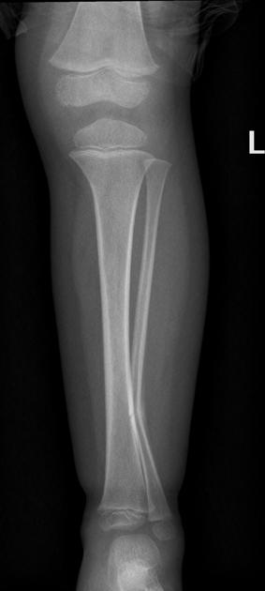

Greenstick fracture⁸

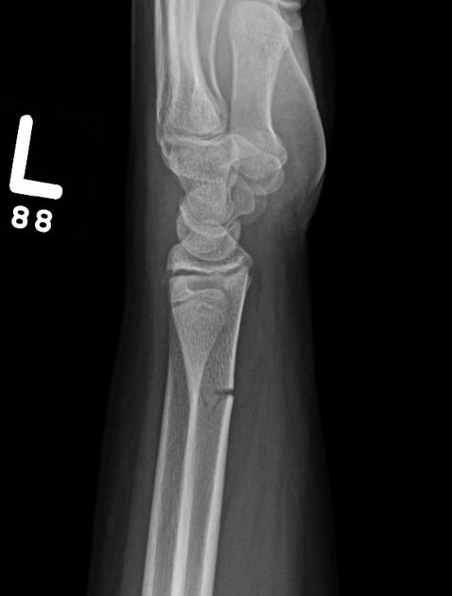

Greenstick Fracture

Torus Fracture: impaction fracture that results in buckling of the cortex.
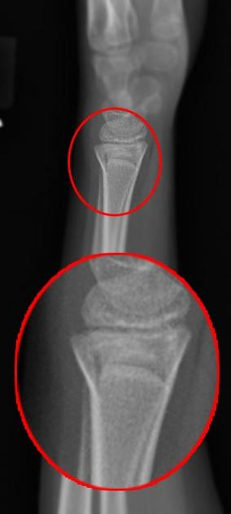

Torus Fracture

Plastic Bowing: this is a type of incomplete fracture with microfractures which are seen
Plastic bowing of the ulna with a fracture of the radius

EPIPHYSEAL FRACTURES
These fractures which constitute of 15 to 20% of childhood fractures are those which involve the growth plate of the physeal region of the bone.
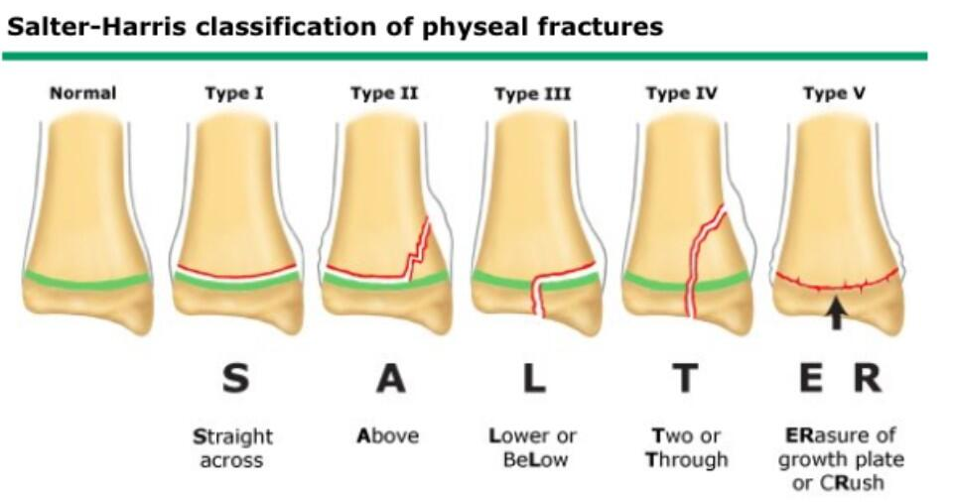
These type of fractures are determined with the use of the Salter Harris classification of epiphyseal fractures in which type I to V are described by Salter Harris and type VI to IX were added subsequently by Rang and Ogden.

Type I
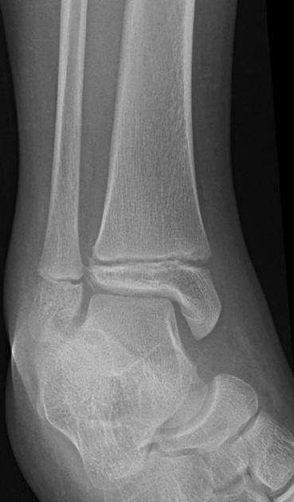
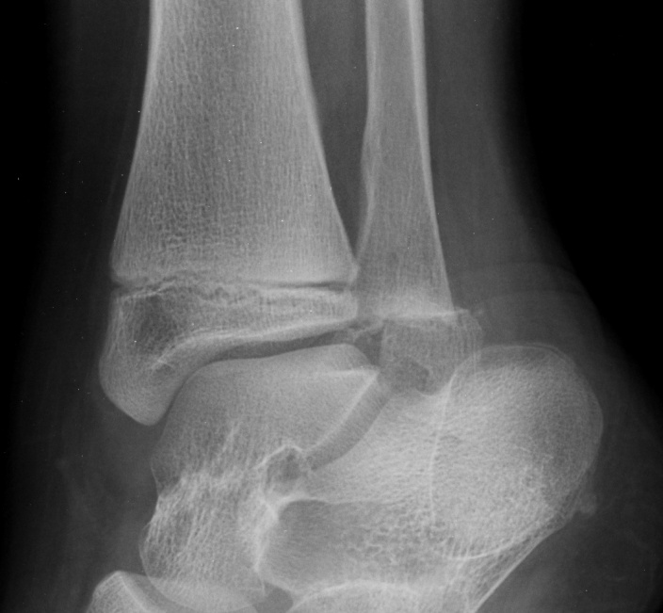Type I Salter Harris Fracture ⁸

Type II Salter Harris Fracture

Type III
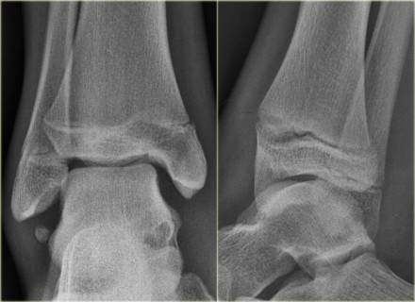

Type III Salter Harris Fracture

Type IV
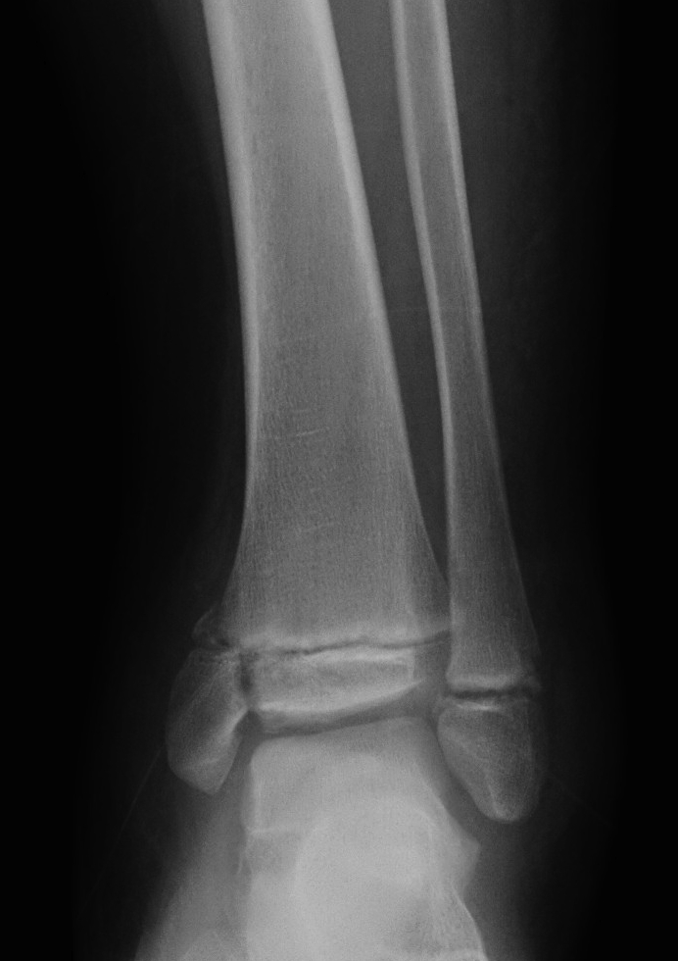

Type IV Salter Harris Fracture

Type V
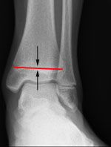

Type V Salter Harris Fracture⁹

Type VI
This type was decribed by Rang and involves the perichondrial ring or the periosteum of the physis. During the repairing process there may be an osseus bridge to develop between the metaphysic and the epiphysis.
Type VII, VIII and IX
These perichondral fractures may disrupt the physeal blood supply and may give rise to growth disturbances. Type VII is an osteochondral fracture of the articular portion of the epiphysis. Type VIII is the fracture of the metaphysic and type IX is avulsion fracture of the periosteum.

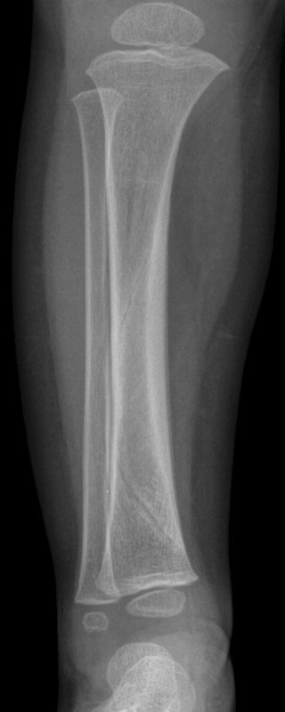
Toddlers Fracture

Non displaced of spiral fracture of the midshaft of the tibia usually found in children who have just begun to walk. Usually best viewed by an oblique view.¹⁰

Healing and Remodelling
Due to the fracture being located near the growth plate of the bone, there may be a disturbance in the growth that takes place in subsequent years. These will depend on the skeletal age of the child, the proximity of the fracture to the growth plate, and the severity in the displacement of fragments.
Conclusion
In conclusion, identifying and describing a fracture requires experience and also thoroughness in the process of examination. As mentioned in the preceding pages knowledge of the normal anatomical variations of fractures will also have to be noted so that a misdiagnosis is not made. If in doubt it would be more advisable to seek the advice of a radiologist. As physiotherapists we should be able to identify a fracture within the peadiatric age group and we should be aware of the differences as compared to their adult counterparts. Understanding the different patterns of trauma to a child and also the radiological features of the fractures would be very essential to provide the best care to our patients. Although children have the advantage of rapid healing fractures, the downside of the process is the chances for re-fractures¹¹. We should be aware of this when treating a child with a fracture.
Fracture management being a major concern for the physiotherapist, he should be able to use the tools of radiology in assessment and diagnosis of a fracture to the best of his ability.

REFERENCES
- Accessory bones of the foot. Image on the Internet available from http://radiopaedia.org/articles/accessory-ossicles-of-the-foot
- Accessory bones of the wrist. Image on the Internet available from http://radiopaedia.org/articles/accessory-ossicles-of-the-wrist
- Image on the Internet available from http://www.learningradiology.com/
- Synovial chondramatosis. Image on the Internet available from http://radiopaedia.org/articles/primary-synovial-chondromatosis
- Image on the Internet available from Teaching Files www.eurorad.org
- Image on the Internet available from http://www.mypacs.net/
- Image on the Internet available from www.raddaily.com
- Image on the Internet available from www.radiopedia.org
- Image on the Internet available from http://orthoinfo.aaos.org/
- Toddlers fracture. Image on the Internet available from. http://www.med-ed.virginia.edu/courses/rad/peds/ms_webpages/ms2canatomy.html
- Pediatric Fractures. Article available from http://learnpediatrics.com/body-systems/musculoskeletal-system/pediatric-fractures/

